Week #5

Objective: For students to get some practice of:

- To understand the concept of Constructors and Destructors
. (No argument and with Argument Constructors)
- Problem solving with classes
  - Writing formal Class description
    - Determining data types for member data
    - Member Function prototypes
  - Translating class descriptions into class declarations
    - Use of private, public keywords.
    - Data/information hiding
  - Working with objects in various applications
    - Calling member functions
    - Rum-time/actual arguments
    - Default-arguments

Theory:
A class can be viewed as a customized ‘struct’ that encapsulates data and function. Format of a class definition:
class your_class_name
{ member_access_specifier:
data members;
member_access_specifier:
member_functions();
};
When cin and cout are used to perform I/O, actually objects are created from istream and ostream respectively that has been defined in iostream header file.

Building a Class
#include <iostream>
using namespace std;
class smallobj //declare a class
{
private:
int somedata; //class data
public:
void setdata(int d) //member function to set data
{ somedata = d; }
void showdata() //member function to display data
{
cout << “Data is ” << somedata << endl; }
};

void main()
{
smallobj s1, s2; //define two objects of class smallobj
s1.setdata(1066); //call member function to set data
s2.setdata(1776);
s1.showdata(); //call member function to display data
s2.showdata();
}

Lab Exercise:
Q #1.
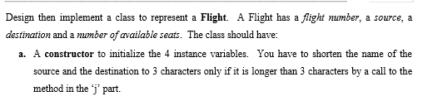
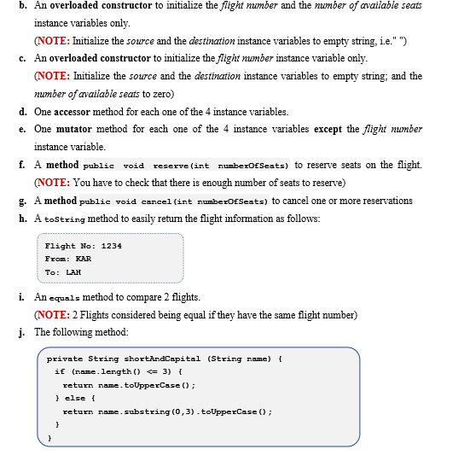
Create the object of the flight class and apply the defined methods.

Output:
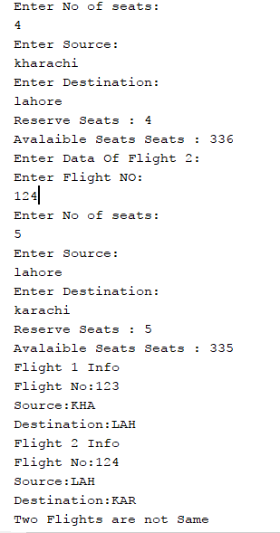
Q#2. 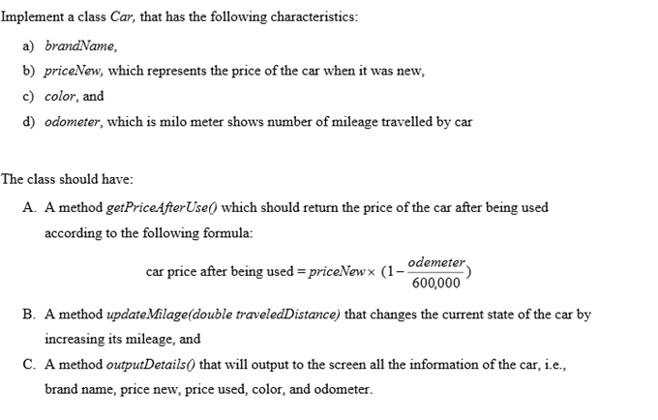

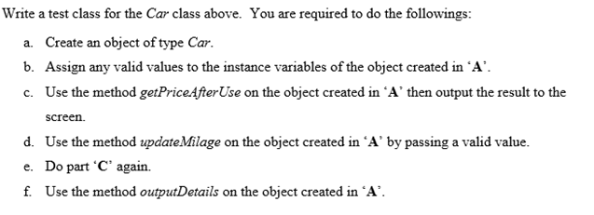

Output:


Q#3.